

**Independent University, Bangladesh**

**Department of Computer Science & Engineering**

**SEN 653: Software Quality Assurance, Testing and Reliability**

**(Autumn 2020)**

**Term Paper**

**Test Plan:**

Learning Management System

**Prepared by**

Md. Tarek Hasan, 2031276

Israt Zahan Safia, 2022928

Farhina Akter, 2022927

Md. Ilias, 1910737

Nusrat Tahsin Kamaly, 1610152

Anupom Hossain Meraj, 1530851.

**Date:** 20-01-2021

Table of Contents

Introduction 3

Scope 3

In Scope 3

Out of Scope 3

Goals & Objectives 3

Primary goals & objective 3

Secondary goals & objective 3

Team Members 4

Tasks 4

Roles & Responsibilities 4

Testing Methodology & Strategy 5

Overview 5

Usability Testing 5

Unit Testing 5

White Box Testing 5

Black Box Testing 5

System and Integration Testing 5

Performance and Stress Testing 5

Smoke Testing 5

User Acceptance Testing 5

Regression Test 5

Batch & Beta Testing 5

Final Release Test 5

Test Completeness 5

Test Approach (Testing techniques and models) 6

Techniques 6

Models 6

Team organogram 7

Hardware & Environment Requirements 8

Milestones / Deliverables 9

Test activities, testing artifacts, participents during each development phase 10

Assumption & Risk 11

Tools 12

Approval 12

# Introduction

## Scope

### In Scope

### Out of Scope

## Goals & Objectives

### Primary goals & objective

### Secondary goals & objective

## Team Members

## Tasks

## Roles & Responsibilities

# Testing Methodology & Strategy

## Overview

## Usability Testing

## Unit Testing

## White Box Testing

## Black Box Testing

## System and Integration Testing

## Performance and Stress Testing

## Smoke Testing

## User Acceptance Testing

## Regression Test

## Batch & Beta Testing

## Final Release Test

## Test Completeness

# Test Approach (Testing techniques and models)

## Techniques

## Models

# Team organogram

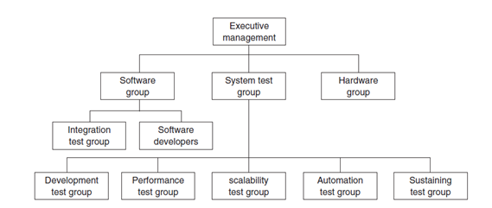

# Hardware & Environment Requirements

# Milestones / Deliverables

# Test activities, testing artifacts, participents during each development phase

# 

# Assumption & Risk

# Tools

# Approval